**K2S Downloader**

**Folder Monitoring Software Installation:**

[ffmpeg.com](https://www.gyan.dev/ffmpeg/builds/)

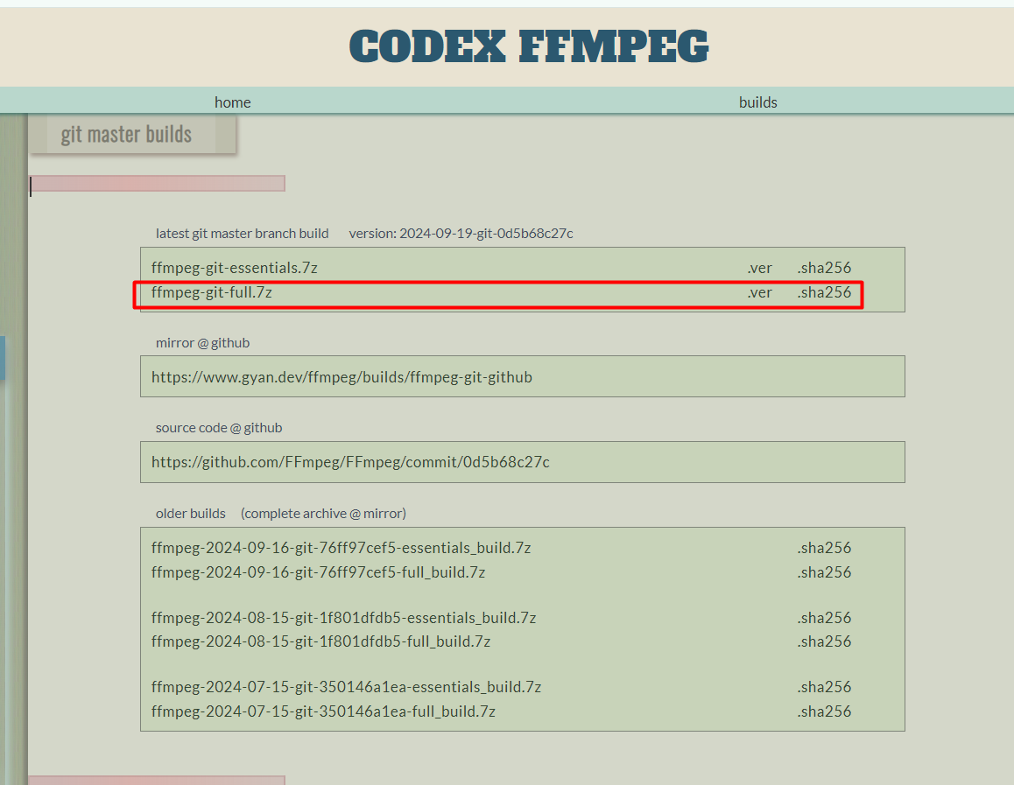

• **Extract the files:**

* After downloading the archive, use an archive program like 7-Zip to extract the files.
* Extract all the content to a folder (e.g., C:\ffmpeg).

• **Configure the system path (Environment Path):**

* Open **Control Panel** and search for "Environment Variables."
* Click on **Edit the system environment variables**.
* In the new window, click on **Environment Variables**.
* In the **System variables** section, look for and select the **Path** variable, then click **Edit**.
* Click **New** and add the path to the **bin** directory of the folder where you extracted FFmpeg (e.g., C:\ffmpeg\bin).
* Click **OK** to save the changes.

• **Verify installation:**

* Open a **Command Prompt** window (by pressing **Win + R**, then typing cmd).
* Type the command:

Copy code

ffmpeg -version

* If the installation is correct, you should see details about the installed version of FFmpeg.

**Python Installation:**

1. **Install Python:**
   * Go to the official Python website and download the latest stable version (preferably Python 3.10 or later).
   * Make sure to check the "Add Python to PATH" option before starting the installation.
   * Proceed with the installation.
2. **Verify the Python installation:**
   * Open Command Prompt (press **Windows + R**, type cmd, and press Enter).
   * Type the command:

python --version

* + If Python is correctly installed, you should see the installed Python version.

1. **Install and Configure pip:**
   * pip is the package manager for Python. It should be automatically installed along with Python.
2. **Verify if pip is installed:**
   * Run the following command in Command Prompt:

pip --version

* + You should see the installed pip version.

1. **If pip is not installed**, you can install it by running the following command:

python -m ensurepip --upgrade

**K2S Downloader Software Installation:**

1. **Create a folder for the K2S Downloader project:**
   * Create a folder where you'll place the script files (you can use File Explorer):
     + Example: D:\k2s-downloader
   * Move all your project files (main.py, k2s.py, utils.py, requirements.txt) into this folder.
2. **Open Command Prompt and navigate to the project folder:**
   * In Command Prompt, use the cd command to navigate to the folder where you saved the script files:

cd D:\k2s-downloader

1. **Create a virtual environment (optional but recommended):**
   * This step creates an isolated virtual environment to avoid conflicts with other globally installed packages on your system.
   * Create a virtual environment in the current folder:

python -m venv venv

* + Activate the virtual environment:

venv\Scripts\activate

* + After activating the virtual environment, your prompt should look like this:

(venv) D:\k2s-downloader>

1. **Install the project dependencies:**
   * The requirements.txt file contains all the necessary packages for the project. To install them, run:

pip install -r requirements.txt

* + This step will install all the required packages for your project to function (such as requests, tqdm, pillow, etc.).

Thank you for your patience. Here's the translation of the full text you provide

**Folder Monitoring Software Installation:**

1. **Extract the files:**
   * After downloading the archive, use an archive program like 7-Zip to extract the files.
   * Extract all the content to a folder (e.g., C:\ffmpeg).
2. **Configure the system path (Environment Path):**
   * Open **Control Panel** and search for "Environment Variables."
   * Click on **Edit the system environment variables**.
   * In the new window, click on **Environment Variables**.
   * In the **System variables** section, look for and select the **Path** variable, then click **Edit**.
   * Click **New** and add the path to the **bin** directory of the folder where you extracted FFmpeg (e.g., C:\ffmpeg\bin).
   * Click **OK** to save the changes.
3. **Verify installation:**
   * Open a **Command Prompt** window (by pressing **Win + R**, then typing cmd).
   * Type the command:

Copy code

ffmpeg -version

* + If the installation is correct, you should see details about the installed version of FFmpeg.

**Python Installation:**

1. **Install Python:**
   * Go to the official Python website and download the latest stable version (preferably Python 3.10 or later).
   * Make sure to check the "Add Python to PATH" option before starting the installation.
   * Proceed with the installation.
2. **Verify the Python installation:**
   * Open Command Prompt (press **Windows + R**, type cmd, and press Enter).
   * Type the command:

css

Copy code

python --version

* + If Python is correctly installed, you should see the installed Python version.

1. **Install and Configure pip:**
   * pip is the package manager for Python. It should be automatically installed along with Python.
2. **Verify if pip is installed:**
   * Run the following command in Command Prompt:

css

Copy code

pip --version

* + You should see the installed pip version.

1. **If pip is not installed**, you can install it by running the following command:

css

Copy code

python -m ensurepip --upgrade

**K2S Downloader Software Installation:**

1. **Create a folder for the K2S Downloader project:**
   * Create a folder where you'll place the script files (you can use File Explorer):
     + Example: D:\k2s-downloader
   * Move all your project files (main.py, k2s.py, utils.py, requirements.txt) into this folder.
2. **Open Command Prompt and navigate to the project folder:**
   * In Command Prompt, use the cd command to navigate to the folder where you saved the script files:

bash

Copy code

cd D:\k2s-downloader

1. **Create a virtual environment (optional but recommended):**
   * This step creates an isolated virtual environment to avoid conflicts with other globally installed packages on your system.
   * Create a virtual environment in the current folder:

Copy code

python -m venv venv

* + Activate the virtual environment:

Copy code

venv\Scripts\activate

* + After activating the virtual environment, your prompt should look like this:

mathematica

Copy code

(venv) D:\k2s-downloader>

1. **Install the project dependencies:**
   * The requirements.txt file contains all the necessary packages for the project. To install them, run:

Copy code

pip install -r requirements.txt

* + This step will install all the required packages for your project to function (such as requests, tqdm, pillow, etc.).

**How to Resume Downloads After Closing Command Prompt:**

1. **Open Command Prompt again:**
   * Press **Windows + R**, type cmd, and press Enter.
2. **Navigate to the k2s-downloader folder:**
   * Type the following command:

D:

Then:

cd \k2s-downloader

1. **Activate the virtual environment (if you created one):**
   * If you created a virtual environment, activate it again:

venv\Scripts\activate

1. **Running the script:**
   * After ensuring you're in the project folder and the virtual environment is activated (if you're using one), run the command to start a new download: Example:

python main.py https://k2s.cc/file/fgdfg514ds/KPc19.mp4 --filename KPc19.mp4 --split-size 20mb

General reference for starting downloads:

python main.py <link_k2s> --filename <filename> --split-size 20mb

### ****Stopping a Process in Command Prompt:****

If you need to stop a running process in Command Prompt, press:

Ctrl + C

**This is everything! Thank you for your attention!**